WEEKLY BEAPS

BEALIBA PRIMARY SCHOOL

Wednesday 15th December Number -18
School Calendar
Term 4 2021

Thursday & Friday Casual dress

Friday 17th December Last day term 4- 1:15 finish

Term 1 2022
Friday 28th February Teachers back at school
Monday 31st February Teachers PD
Tuesday 1st February Students start 9am.

MAINTENANCE FUNDING!!!!!!

GREAR NEWS-
We have been notified that we will receive $105,000 in funding for maintenance on the school building in 2022.

Last day of school
Term four finishes this Friday,
17th December at 1.15pm.

Thank you to everyone for their support of the school throughout 2021. It has been a busy and different year and we hope that 2022 will ‘back to normal’.

Casual Dress
The last two days of school will be casual clothes for the students.

First day of school 2022
Students will commence school on Tuesday 1st February at 9.00am.

Swimming
Students will be travelling to Dunolly Pool for swimming lessons starting Monday 7th February to Friday 18th February (two weeks) weather permitting. Times and arrangements to be confirmed.

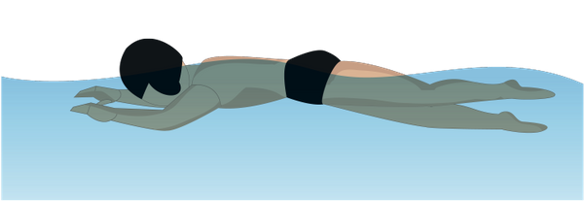

Merry Christmas and a happy 2022
On behalf of myself and all staff we wish all students and families a very merry Christmas and a very happy 2022.

