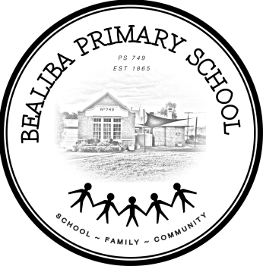
BEALIBA PRIMARY SCHOOL NO 749

9 Grant St Ph: 5469 1256
Bealiba Vic 3475 Fax: 5469 1341
ABN: 88 843 939 776 www. bealibaps.vic.edu.au email: bealiba.ps@edumail.vic.gov.au

Newsletter Notice re: Parent Payment Arrangements for the year 2022.

Each year a notice is included in the newsletter stating that:

Bealiba Primary School Council moved that they would not be charging school fees and that these costs would be covered by school funds.

The newsletter will also include a link to the Victorian DET Parents Payment Policy page https://www2.education.vic.gov.au/pal/parent-payment/policy

It was also moved that each student would be provided with either 1school jacket & 1 school top OR
2 school tops.

Excursions are minuted individually as they occur and are also covered by School funds enabling parent support of the programs.

It is noted that the ‘Camps, Sports & Excursion Fund’ Payments are utilised in payments for these activities.

If any parent payment is requested it is acknowledge that appropriate support will be offered to parents.

